Student ID: 103596586

Name: Jad Mashtoub

# Setup Screenshot

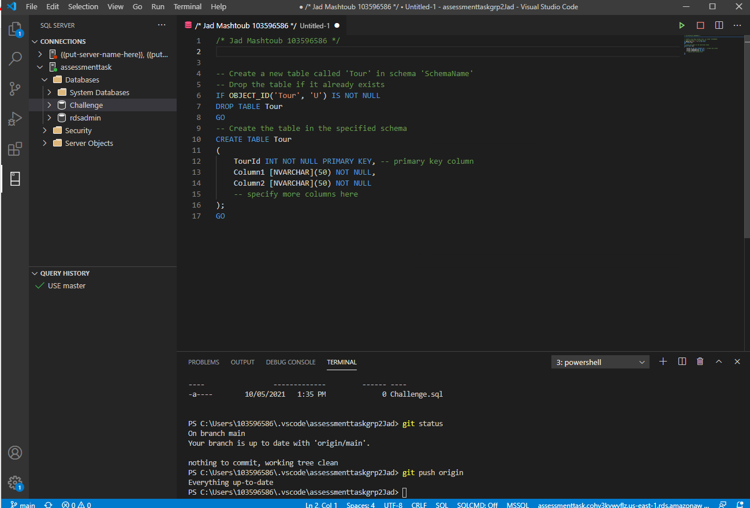

# Task 2 Screenshot

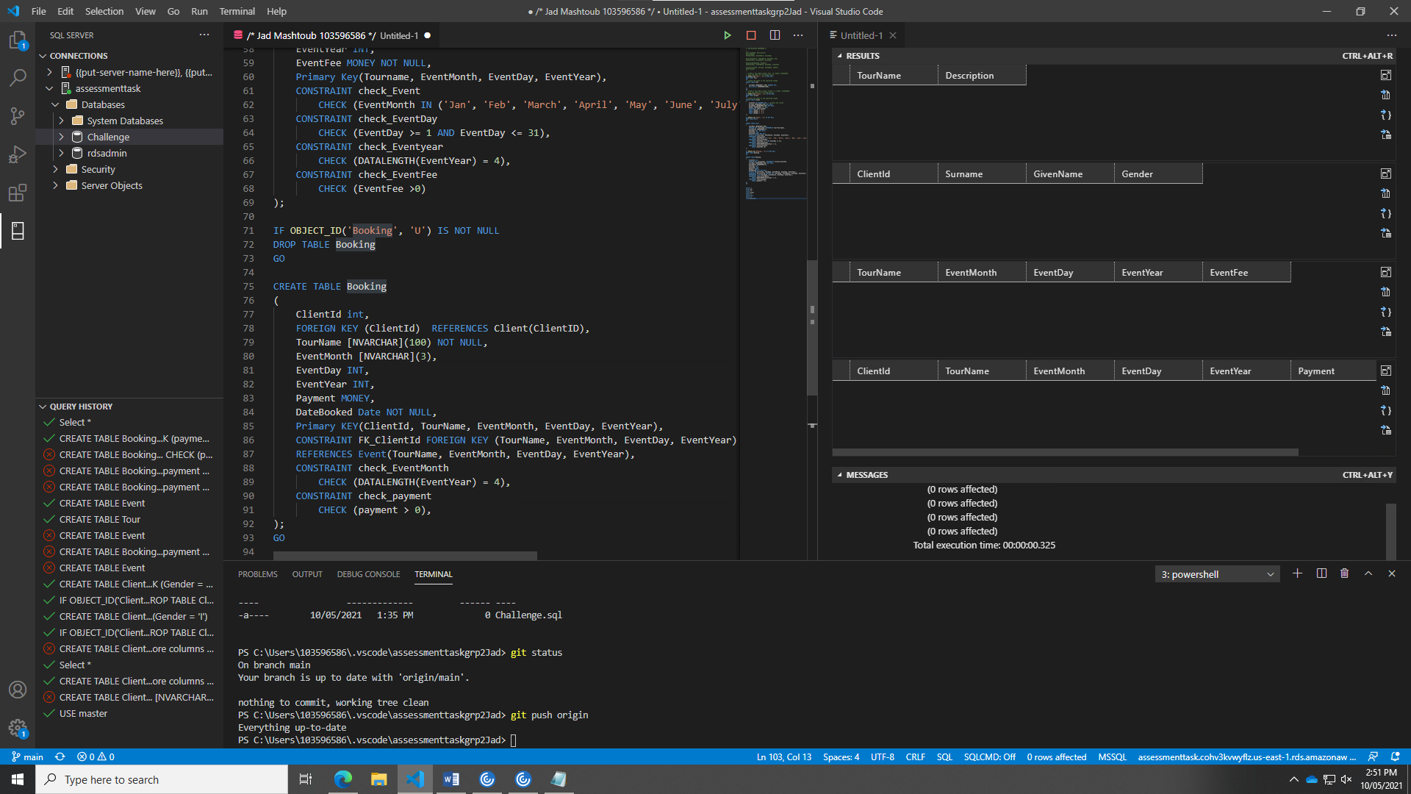

# Task 3 Screenshot

